

CYTOCOPASI

V1.0 User Manual

12 APRIL 2023

SCIENTIFIC COMPUTING RESEARCH UNIT CHEMISTRY DEPARTMENT ROOM 6.37, 6TH LEVEL PD HAHN BUILDING, NORTH LANE UNIVERSITY OF CAPE TOWN RONDEBOSCH, 7701

EMAIL: adminscru@uct.ac.za

Table of Contents

CytoCopasi Cytoscape App 1.0 3

License 4

Installation 5

CytoCopasi Interface – Panel 6

CytoCopasi Interface – Network View 7

Visual Style 8

Nodes 8

Edges 9

Tables 9

Creating a New Model 10

New Model Dialog 10

New Species Dialog 11

New Reaction Dialog 12

Chemical Equation 12

Rate Law from CytoCopasi’s Function Database 13

Rate Law - Custom 13

Parameter Query via BRENDA 14

Saving Models 16

Importing a Model – KEGG Networks 16

KEGG Subnetwork Extraction 17

Editing Model Elements 18

Simulation Tasks 19

Time Course Simulation 19

Dynamic Simulation 20

Steady-State Analysis 21

Comparative Simulation Analysis 22

Parameter Perturbations on the Same Model 25

CYTOCOPASI MANUAL

# CytoCopasi Cytoscape App 1.0

CytoCopasi is a Cytoscape [1] app that enables modeling, importing, simulating, and comparing biochemical reaction networks. It uses the Java bindings of Complex Pathway Simulator (COPASI)[2] for quantitative systems biology modeling.

Besides the regular ODE-based tasks, such as time course simulation and steady state analysis, users can also superimpose and compare two chemical reaction networks (e.g., a healthy vs diseased state) to display the concentration deviations. Users can also manually perturb a model by modifying one or more parameters of their choice (e.g., the activity of an enzyme or the initial concentration of a drug molecule) and visualize the downstream effects on simulated concentration profile.

**Features:**

* Systems Biology Markup Language (SBML)[3] support
* Ability to import local SBML files
* Direct connection to Kyoto Encyclopedia of Genes and Genomes (KEGG)[4] for importing pathways and converting them into SBML
* Ability to extract KEGG modules as subnetworks
* Supports BRaunschweig ENzyme Database (BRENDA)’s [5] SOAP access for enzyme functional data queries
* Comparative systems biology analysis to visualize deviations between two reaction networks
* Perturbation analysis to visualize downstream effects of mutations or drug treatment
* Optional dynamic simulation via SBMLSimulator[6]

# License

The GNU General Public License is a free, copyleft license for software and other kinds of works.

The licenses for most software and other practical works are designed to take away your freedom to share and change the works. By contrast, the GNU General Public License is intended to guarantee your freedom to share and change all versions of a program--to make sure it remains free software for all its users. We, the Free Software Foundation, use the GNU General Public License for most of our software; it applies also to any other work released this way by its authors. You can apply it to your programs, too.

When we speak of free software, we are referring to freedom, not price. Our General Public Licenses are designed to make sure that you have the freedom to distribute copies of free software (and charge for them if you wish), that you receive source code or can get it if you want it, that you can change the software or use pieces of it in new free programs, and that you know you can do these things.

To protect your rights, we need to prevent others from denying you these rights or asking you to surrender the rights. Therefore, you have certain responsibilities if you distribute copies of the software, or if you modify it: responsibilities to respect the freedom of others.

For example, if you distribute copies of such a program, whether gratis or for a fee, you must pass on to the recipients the same freedoms that you received. You must make sure that they, too, receive or can get the source code. And you must show them these terms so they know their rights.

Developers that use the GNU GPL protect your rights with two steps: (1) assert copyright on the software, and (2) offer you this License giving you legal permission to copy, distribute and/or modify it.

For the developers' and authors' protection, the GPL clearly explains that there is no warranty for this free software. For both users' and authors' sake, the GPL requires that modified versions be marked as changed, so that their problems will not be attributed erroneously to authors of previous versions.

Some devices are designed to deny users access to install or run modified versions of the software inside them, although the manufacturer can do so. This is fundamentally incompatible with the aim of protecting users' freedom to change the software. The systematic pattern of such abuse occurs in the area of products for individuals to use, which is precisely where it is most unacceptable. Therefore, we have designed this version of the GPL to prohibit the practice for those products. If such problems arise substantially in other domains, we stand ready to extend this provision to those domains in future versions of the GPL, as needed to protect the freedom of users.

Finally, every program is threatened constantly by software patents. States should not allow patents to restrict development and use of software on general-purpose computers, but in those that do, we wish to avoid the special danger that patents applied to a free program could make it effectively proprietary. To prevent this, the GPL assures that patents cannot be used to render the program non-free.

# Installation

#### System Requirements

* Windows, Linux, Unix, or MacOS operating system
* Cytoscape 3.8. or above <https://cytoscape.org/>
* Java OpenJDK 11.0.14 or above

#### IMPORTANT: Native Library

The .zip file contains three native library files, .dll, jnilib, and .so for Windows, MacOS, and Linux/Unix, respectively.

Since COPASI is written in C++, COPASI classes are compiled into copasi.jar contained within the main bundle. However, this jar file will only work when the accompanying native library is in the java.library.path.

Work is underway to automate native library access. For the time being, before initializing CytoCopasi, make sure to copy the appropriate native file to a directory in your java.library.path

**How to see the current value of the java.library.path variable**

Java.library.path usually contains multiple directories, but the user can copy the native library to any of them. For all OS types: Open Terminal and type

java -XshowSettings:properties

(find the java.library.path section in the output)

**To Copy the Native Library to Your java.library.path:**

* Download the application and supporting files from <https://github.com/scientificomputing/CytoCopasi>
* Extract the folder from .zip

**Mac OS X**

* Go to CytoCopasi-main/Native Libraries/

The correct type of Mac OS X native library depends on your Mac processor. If you are not sure, this [article](https://www.makeuseof.com/how-to-find-out-if-your-mac-uses-intel-or-apple-silicon/) explains how to find out

* For intel (x64): go to Mac OS X (Intel)
* For M1/M2 chips: go to Mac OS X M1M2
* Open terminal
* sudo cp libCopasiJava.jnilib <the selected java.library.path directory>
  + ex: sudo cp libCopasiJava.jnilib /Library/Java/Extensions
* Enter your user password when prompted.

**Windows:**

* Go to CytoCopasi-main/Native Libraries/Windows
* Run terminal (Windows PowerShell) as administrator (this option will appear when you right-click on the terminal icon.
* cp CopasiJava.dll <the selected java.library.path directory>

**Linux/Unix**

* Go to CytoCopasi-main/Native Libraries/Linux
* Open terminal
* sudo cp libCopasiJava.so <selected java.library.path directory>

#### Installation

Since CytoCopasi is not yet available on App Store, you need to install it in one of the following two methods.

1. **App Manager**

Click on “Install from file” on the App Manager Dialog, and find the downloaded

.jar file

1. **Copy the downloaded jar file**

Copy the jar file to [...]/CytoscapeConfiguration/3/apps/installed

Once the installation is complete, you will see the CytoCopasi tab on the left panel space (see Figure 1).

# 2- CytoCopasi Interface – Panel

This section includes an overview of the CytoCopasi panel components.

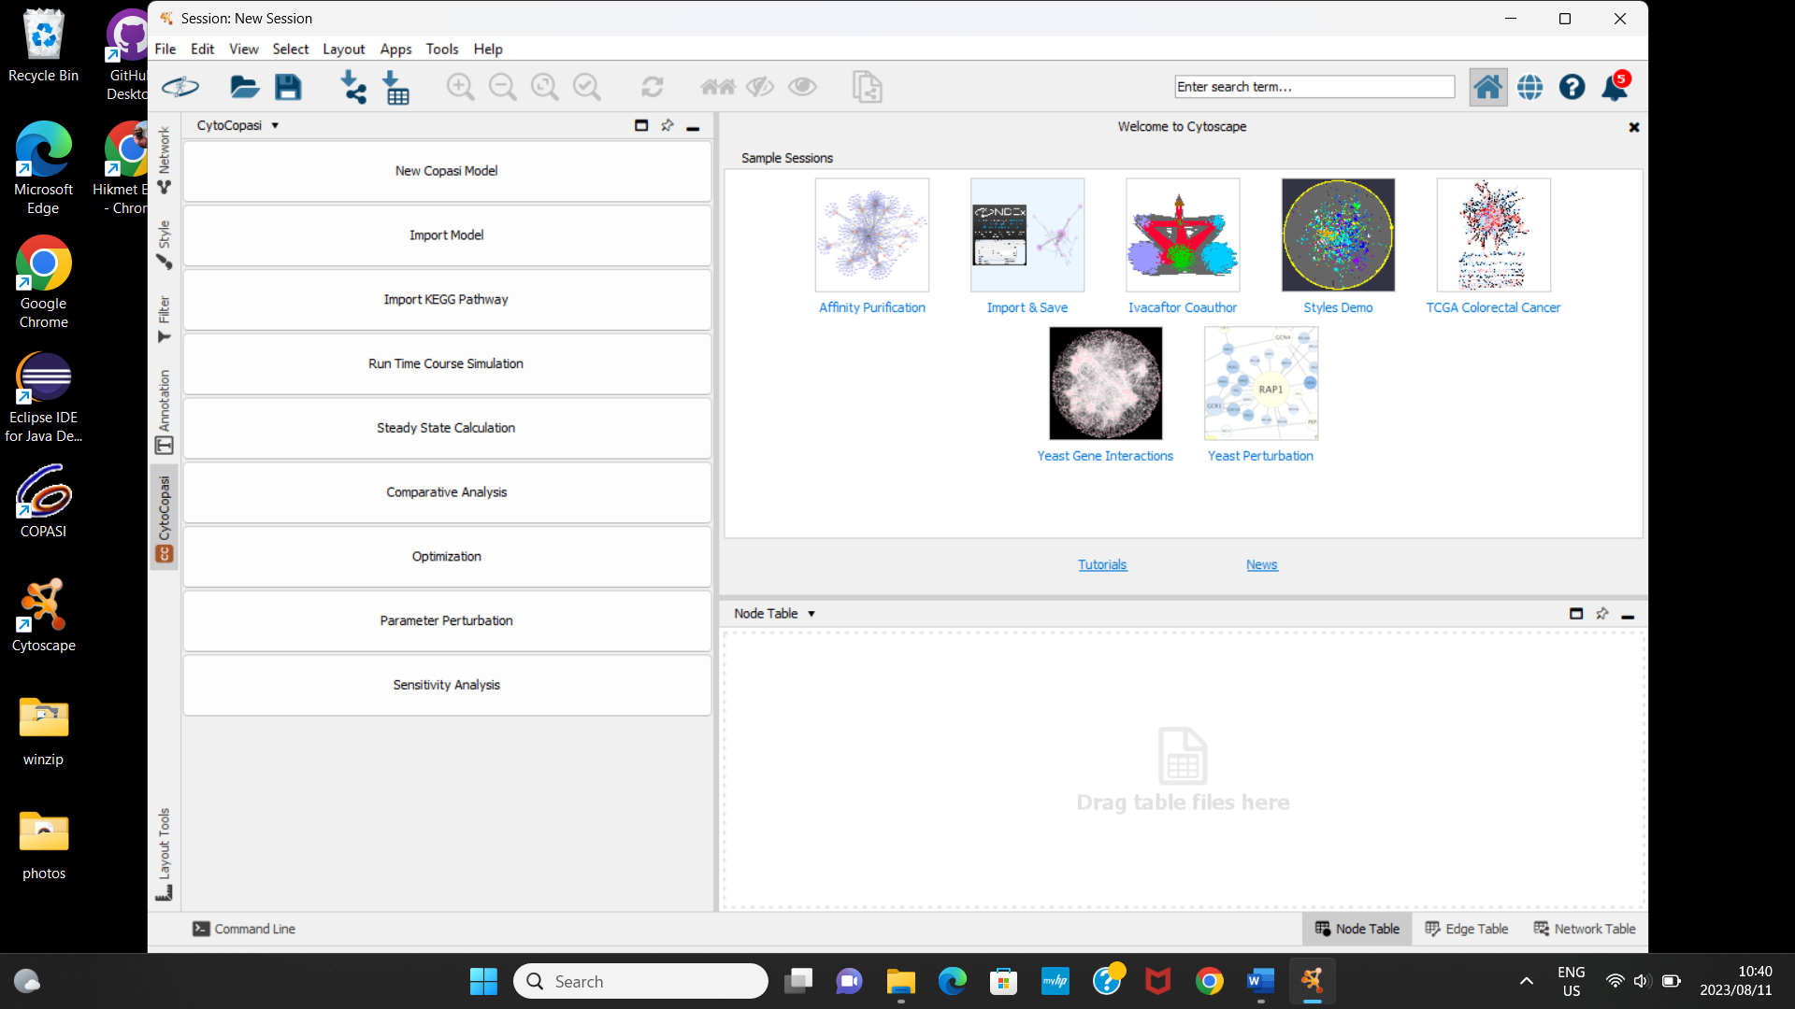

*Figure 1: CytoCopasi Panel*

**New Copasi Model:** Click this button to start manually curating a new COPASI model.

**Import Model:** Import an SBML (.xml) or COPASI (.cps) file

**Import Model From KEGG:** This button brings up a dialog to select a KEGG pathway to download, convert to SBML, and import.

**Time Course Simulation:** Run a deterministic time course simulation on a new or imported model.

**Steady State Analysis:** Determine steady-state in new or imported models

**Optimization:** Minimize an objective function by scanning one or more parameters over a given range.

**Parameter Perturbations:** Run multiple simulations over a range of parameters to determine the dependence of a model value on the parameter.

**Sensitivity Analysis:** Measures how much a sensitive a specific model value (e.g., steady state concentrations or fluxes) to kinetic parameters.

# 3- CytoCopasi Interface – Network View

This section includes an overview of the CytoCopasi Network View Elements



*Figure 2: CytoCopasi Network View - Metabolites are represented with circular nodes, and reactions are represented with square nodes.*

# 3.1- Visual Style

CytoCopasi offers two visual styles, Cy3Copasi and Cy3Sbml[7], for .cps and

.sbml files, respectively. These style files are located in

…/CytoscapeConfiguration/app-data/CytoCopasi/styles.

The appropriate visual style will appear in Cytoscape’s Style tab when the user creates or imports a model.

You can view and customize the style attributes (e.g., node shape, edge color, arrow type) from the properties section of the Style tab.

# 3.2- Nodes

There are two types of nodes in a CytoCopasi model. The circular nodes represent species, or metabolites, while smaller and square-shaped nodes represent reactions. Reaction node colors indicate reversibility of a reaction, where blue means reversible and red means irreversible.

We have chosen to implement node representations for reactions instead of arrows (edges) – only to make the reaction display more meaningful and representative of enzyme-catalyzed reactions.

Users can double-click on the nodes to view and modify the details of these model elements.

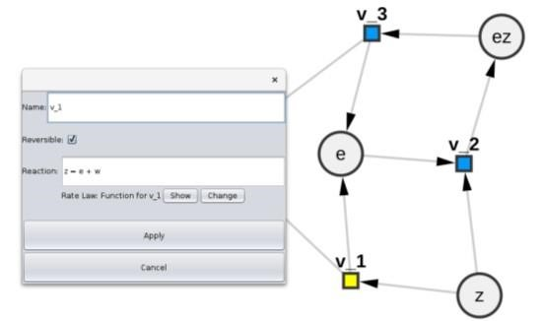 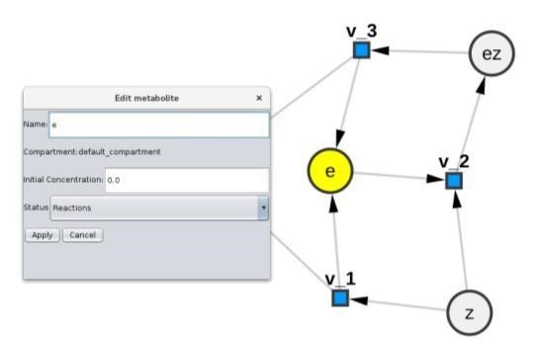

*Figure 3: Dialogs for Viewing and Editing Metabolite and Reaction Specifics*

Finally, users can modify node size, color, and shape from Cytoscape’s Style tab.

## 3.3- Edges

Edges represent the direction of the reaction network. Each species node will be connected to at least one reaction node. Arrows indicate inputs and outputs of the reaction.

The edge will have a single arrow if the reaction is irreversible and a double arrow if it is reversible.

For reactions with inhibitors, the inhibition is depicted with the inhibitor connecting to the reaction node with a T-shaped red dashed arrow.

Users can modify edge style attributes from the Properties section in the Styles tab.

## 3.4- Tables

Node, edge, network tables allow users to overview and change model values.

Node table show summarizes the features of species and reactions.

For species, user can view the following:

* Shared name
* Name: Species
* Type
* Id: Unique ID number assigned by COPASI
* CN: Common Name format assigned by COPASI
* Display Name (usually the same as name and shared name)
* Compartment: The compartment that the species is located in. It will be *default* if the user has not specified it or if it was not specified in the imported model.
* Initial concentration: Species concentration before the simulation. If not specified, it will be 1.0 (units) by default, which the user can change later on.
* Status:
  + Reactions: the concentration/amount of the species is determined by the kinetic laws of the reactions that modify the species (this is the default unless explicitly specified)
  + Fixed: the concentration/amount of the species has a constant value

(which corresponds to the given initial value) o Assignment: the concentration/amount of the species is determined by evaluating the given mathematical expression

* + ODE: the rate of change of the species concentration/amount is determined by an ordinary differential equation

For reactions, the node table contains the following columns:

* Shared name
* Name
* Type: Reaction rev (reversible) or reaction irrev (irreversible)
* Id: Unique ID number assigned by COPASI
* CN: Common Name format assigned by COPASI
* Display Name (usually the same as name and shared name)
* Reversible (box checked if so, blank otherwise)
* Chemical equation
* Rate law: name of the rate law (whether from COPASI’s function database or user-defined)
* Substrates (list of substrates, separated by comma)
* Substrate units
* Products (list of products, separated by comma)
* Product units
* Modifiers (list of inhibitors, separated by comma)
* Modifier units
* Parameter (list of parameters included in the rate law formula) The edge table summarizes reaction type (reversible, irreversible) or if the substrate connecting to the reaction node is an inhibitor.

# 4- Creating a New Model

This section summarizes the steps of creating a new model and the type of input expected from the user.

## 4.1- New Model Dialog

Clicking on the New COPASI Model button reveals a dialog for specifying the general features of the model.

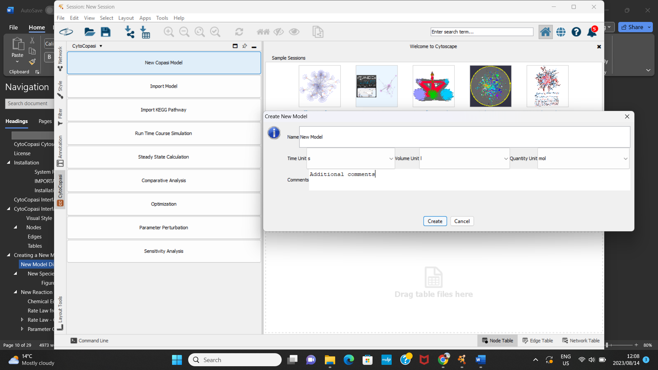

***Figure 4: The Initial Dialog for Creating a Model***

Name: The name of the model

Units: The units assigned here will be applied to the entirety of the model (i.e., concentrations, fluxes, parameters).

Volume: Compartment volume in the volume units the user has specified. Here, the assumption is that the compartment volume is fixed. Future releases will support compartment volume expression in cases where the compartment can expand or shrink depending on concentration changes.

Comments: Cross-reference to literature, other comments you might want to notify the other users about the model.

Clicking on *Create* creates an empty model and a corresponding empty Cytoscape network.

The CytoCopasi panel now displays new buttons that enable users to populate the model.

## 4.2- New Compartment Dialog

Similar to COPASI, species are contained in compartments. The user has the option to define compartments by clicking on “Add New Compartment”.

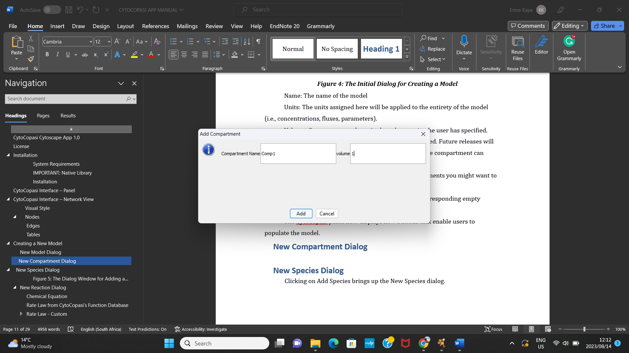

Figure 5: New Compartment Dialog

Note: It is possible to start creating new species or reactions without this step. In that case, CytoCopasi will create a default compartment with a volume of 1 unit.

## 4.3- New Species Dialog

Clicking on Add Species brings up the New Species dialog.

Figure 6: The Dialog Window for Adding a New Metabolite

Name: Name of the metabolite (e.g., Glucose, ATP, C3H7NO)

Initial Concentration: The species concentration before the simulation is run on the model.

Status: Determines how the concentration varies.

* Reactions: the concentration/amount of the species is determined by the kinetic laws of the reactions that modify the species (this is the default unless explicitly specified) o Fixed: the concentration/amount of the species has a constant value (which corresponds to the given initial value) o Assignment: the concentration/amount of the species is determined by evaluating the given mathematical expression
* ODE: the rate of change of the species concentration/amount is determined by an ordinary differential equation

## 4.4- New Reaction Dialog

After creating your model, click on the “New Reaction” button at the bottom of the panel.

Creating a new reaction in CytoCopasi generates one node for each reactant, one reaction node, and one node for each product, followed by the edges to connect the nodes.

You need to define the name of the reaction, its formula, rate law, and corresponding parameter values.

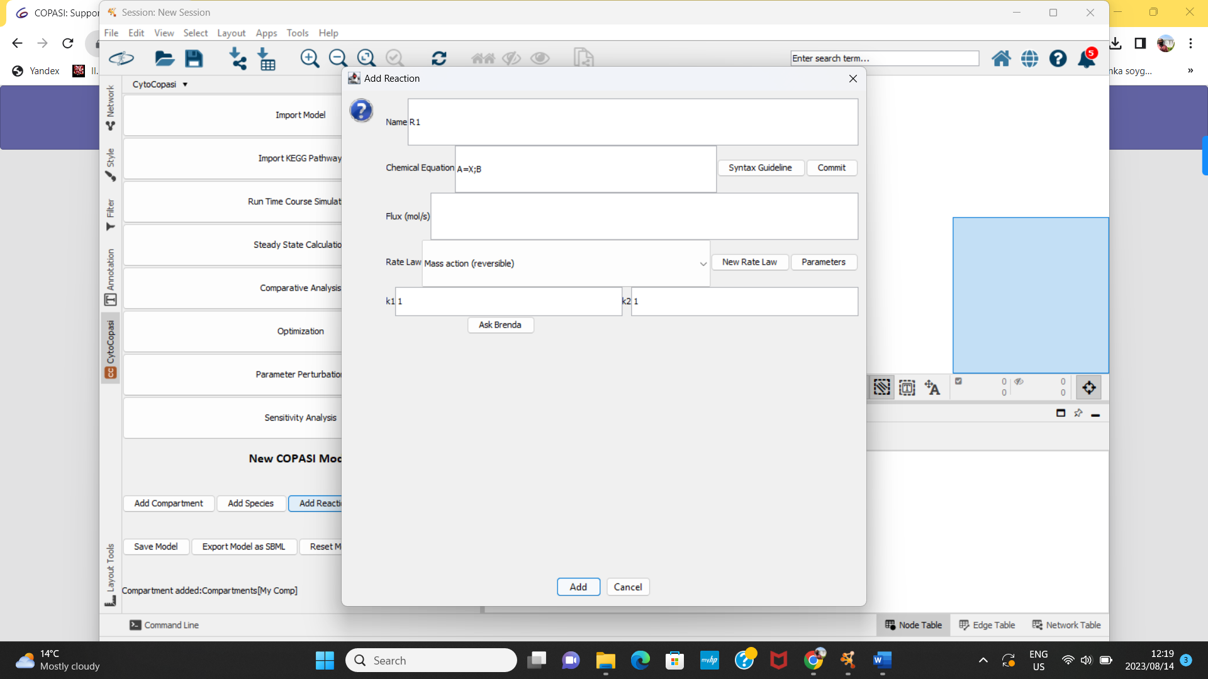

*Figure 7: Creating a New Reaction - involves specifying the chemical equation, the rate law, and assigning parameter values*

### Chemical Equation

The syntax for the reaction formula follows that of COPASI, where “=” indicates a reversible reaction, while “->” denotes an irreversible reaction. Furthermore, if the reaction rate is affected by a modifier metabolite (e.g., an inhibitor), you need to type it following a “;” sign. For instance, the transition of A to X, inhibited by the metabolite B, would be written as follows:

A=X;B

### Rate Law from CytoCopasi’s Function Database

Click on “Commit” to register the chemical equation. This will prompt CytoCopasi to create a list of rate law functions based on the number of reactants, products, and inhibitors. The rate law formulas for these functions are predetermined, so all you need to do is click on “Parameters” to specify the parameter values.

### Rate Law - Custom

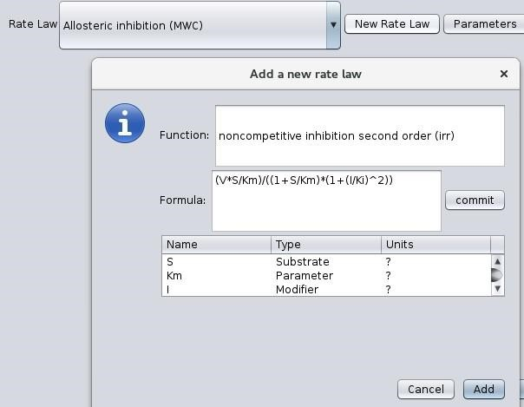

Figure 8: Defining a Custom Rate Law - after committing the rate law formula, you need to assign variables to one of the four types of model entitites: Substrate, Product, Modifier, Parameter

In addition to the function database, CytoCopasi offers the option to assign a custom rate law. Click on “New Rate Law” to open a pop-up dialog, where you can type the formula for your rate law. Click on “Commit” to register the formula.

Next, you need to assign roles to the variables in the formula. By default, each element of the formula has a variable role. You need to specify one of the following roles for each variable: Substrate, Product, Parameter, and Modifier.

### Parameter Query via BRENDA

We often rely on online pathway and enzyme kinetics databases to construct meaningful systems biology models. Through Simple Object Access Protocol (SOAP), CytoCOPASI provides rapid access to BRENDA, a comprehensive enzyme functional database, allowing you to make rapid queries about organism-specific parameters, such as Km, Ki, and Kcat. You can also view the experimental conditions, such as pH and temperature, under which the kinetics experiments were performed.

Before you can use this feature, you need to register and create an account on BRENDA’s website. It is zero-cost.

On the reaction dialog, you need to click on “Parameters” to enable the “Ask BRENDA” button, which appears under the parameter fields.

Enter your login details to sign in. This might take a few seconds.

In the next window, enter the name of the enzyme you want to find parameters for. Select the organism from the dropdown list. Then, specify the parameter you are interested in (Km, Ki, or Kcat). Click “Search”; the query may take a few seconds.

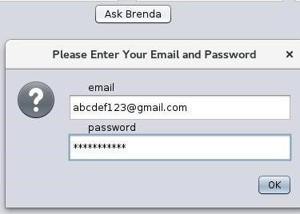

Figure 9: BRENDA Login Window

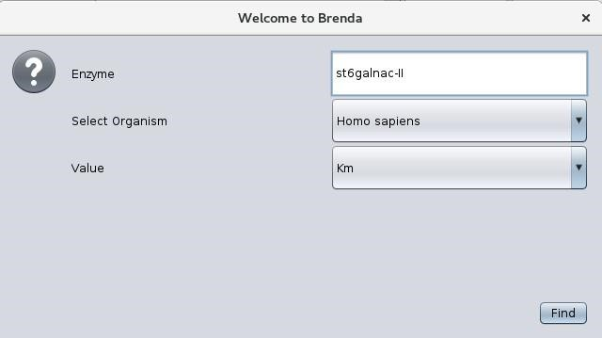

Figure 10: BRENDA Enzyme Query

In BRENDA, enzymes are grouped and stored according to their enzyme commission numbers; however, the same enzyme name can be associated with multiple EC numbers. CytoCOPASI obtains a list of all EC numbers matching your query. You can select the appropriate enzyme based on the full name and synonyms.

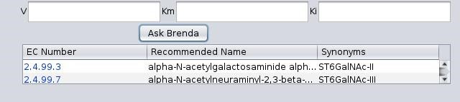

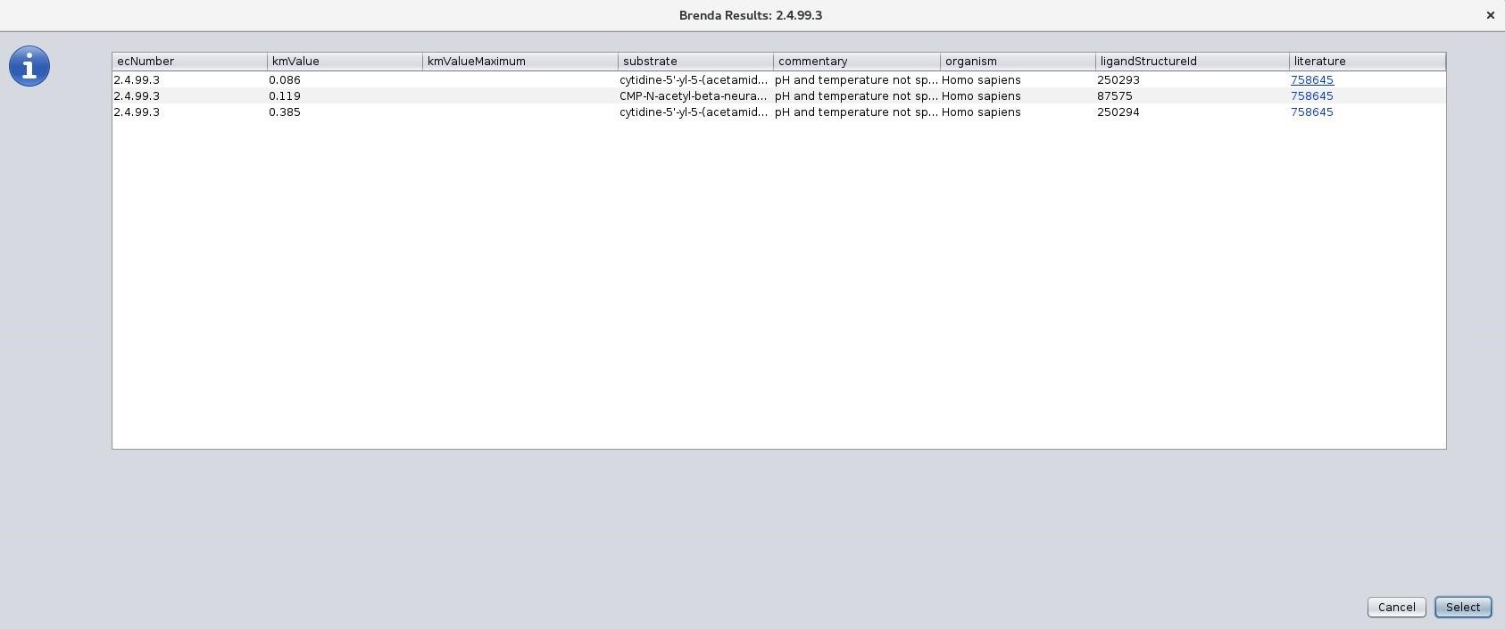

*Figure 11: BRENDA Results - One keyword might return multiple enzymes, so you need to select the appropriate one from the list.*

The results are presented in a table that contains not only the parameter value, but also the range, the substrate, commentary about experimental conditions (e.g., pH and temperature, if specified), substrate structure Id, and the Pubmed reference number hyperlink, which redirects you to the publication for the enzyme kinetics study.

**Note:** You can use the BRENDA search feature on imported models, e.g., when you want to change parameter values or add a new reaction to an existing model.

# 5- Saving Models

You can save your model either as a CPS file by clicking on Save Model or as an SBML file by clicking “Export as an SBML file”.

# 6- Importing a Model – KEGG Networks

You can import CPS and SBML files on your local machine by simply clicking on the “Import Model” button.

CytoCOPASI also supports pathway import from KEGG. Click on “Import Model from KEGG” to bring up the KEGG search bar. You can either manually select the pathway name and organism or type the unique KEGG ID to find the pathway of your interest. Click on “Load” to import the network. CytoCOPASI will download the pathway as a KGML file and use KeggTranslator[8] to convert it to the SBML format. This may take a few seconds.

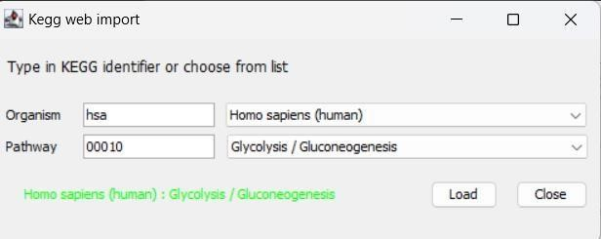

*Figure 12: KEGG Import - Select the organism and pathway name*

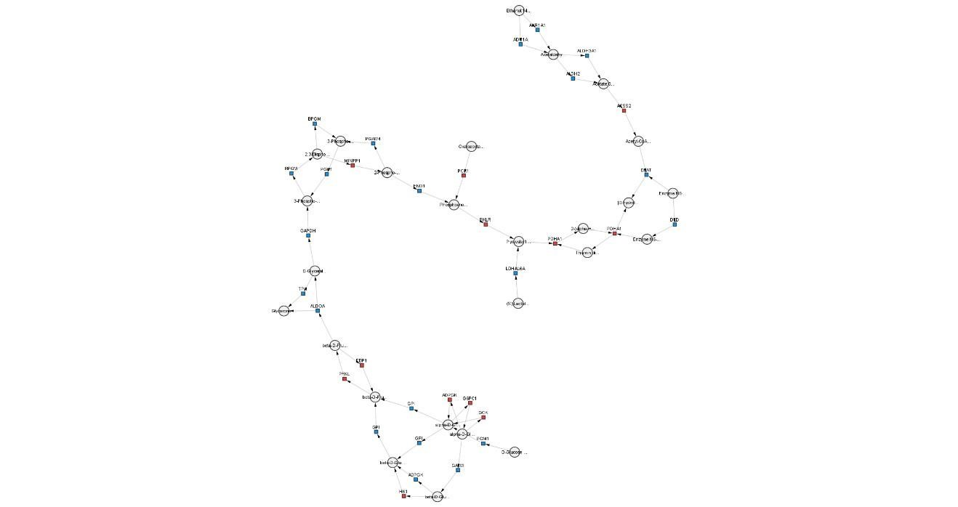

*Figure 13: KEGG Network View - Glycolysis - Glucogenesis*

Once the model is imported, you can add/remove reactions.

## 6.1- KEGG Subnetwork Extraction

Once a KEGG model is imported, a new button “Generate KEGG Subnetwork” will appear on the left panel. This helps isolate parts of the KEGG structure based on the modules of that network.

The list of KEGG modules will appear. Select the module you want to isolate and click “Extract”

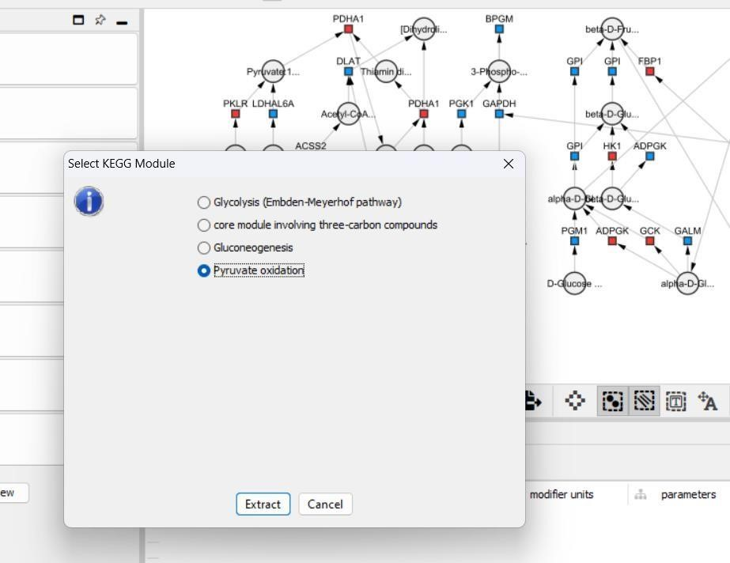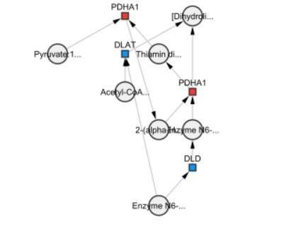

*Figure 14: Extracing The Pyruvate Oxidation Subnetwork from the KEGG Glycolysis Network*

# 7- Editing Model Elements

To view properties of metabolites and reactions, double click on the nodes. Double-clicking on a metabolite node will bring up the metabolite editing dialog, which shows the metabolite name, the compartment it belongs to, initial concentration, and the status (i.e., Fixed, Reaction, Assignment, Time).

Double-clicking on a reaction node will bring up the reaction name, chemical equation, reversibility, and the name of the rate law.

To view the rate law formula, click “Show”.

Click “Edit Reaction” to change the chemical equation and define a new rate law based on that. This means you either add a new metabolite(s) to the reaction of remove one or more metabolites from the reaction (e.g., You want to change A->B to A+ADP ->B+ATP to account for the Adp to Atp conversion). Since the suitable rate laws depend on the number of substrates and products, you need to define the rate law from scratch similar to when creating a new reaction.

Click “Edit Rate Law” to view the parameter values and edit the rate law without changing the chemical equation itself. You can change the rate law by selecting it from the function database, or creating your custom rate law similarly to how you did when creating a reaction from scratch.

You can update parameter values from the table and use BRENDA to look up parameter values.

Click on “Apply” to temporarily save changes to your current model. To save these changes permanently, you need to save the model or export it as an SBML model.

# 8- Simulation Tasks

CytoCopasi supports the simulation tasks found in standalone COPASI.

## 8.1- Time Course Simulation

A time-course simulation task helps users calculate and monitor concentration profiles of metabolites over a given time period.

Running a time-course simulation requires a few parameters:

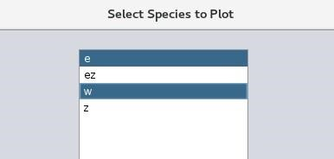

*Figure 15: Time Course Simulation*

*Specifics*

* Duration: The length of the simulation time in time units. For example, if the time unit of your model is in hours, entering “4” means that the simulation will run for 4 hours.
* Intervals: This is the number of checkpoints at which CytoCopasi will take concentration measurements. For example, during a 4h simulation, 100 steps means that concentration will be measured every 0.04 hours or 2.4 minutes.
* Starting time: By default, CytoCopasi will start to track the simulation from t=0, but you can specify a time point such that concentration measurements will begin at that point.

Once these parameters are specified, click on Output Assistant to determine the metabolites you want to plot concentration profiles for. You can select as many metabolites as you like.

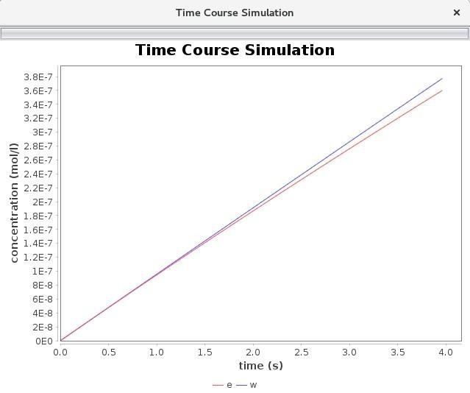

*Figure 16: Time Course Concentration Plot for*

*the Input shown in Fig 15*

CytoCopasi will generate time-course plots on JFreeChart[9], which allows you to customize the plot further.

### Dynamic Simulation

The time-course simulation input dialog also contains a checkbox asking you whether or not you want to run a dynamic simulation. This option is helpful if you want to track the formation or consumption of your metabolites in real life through the third-party application SBMLSimulator.

When the simulation starts, CytoCopasi calls SBMLSimulator and imports the SBML file you are working with. All you need to do is to upload the CSV file for the time course containing the concentration measurements of all metabolites. This file is automatically created and saved under your working directory.

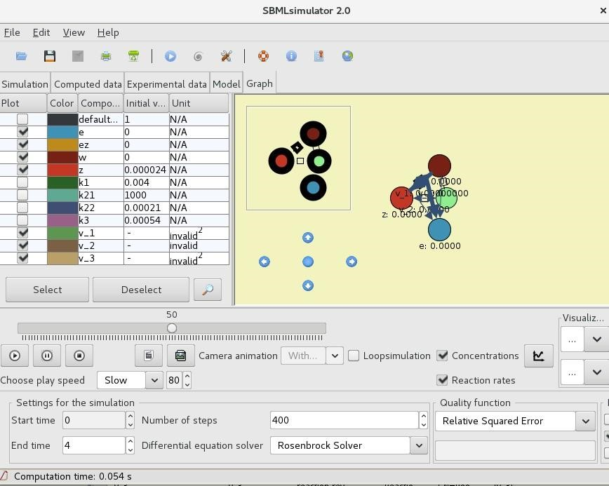

*Figure 17: SBMLSimulator Dynamic Simulations*

## 8.2- Steady-State Analysis

Steady-state is the model state, where the concentrations or particle numbers do not change with time. In terms of the ODE-based simulations, steady-state can be defined as the model state, where the differential concentration profiles are all set to zero.

You can run a steady-state analysis on your model from the Steady State Calculation button.

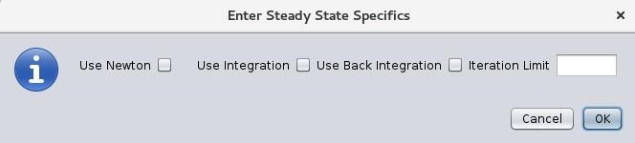

*Figure 18: Steady State Input Dialog*

You can find more details on the steady state calculation methods, such as Newton and Integration on [COPASI’s User Manual. C](https://copasi.org/Support/User_Manual/Methods/Steady_State_Calculation/)heck the appropriate boxes and click OK.

If the model does not reach steady state, CytoCopasi will throw an error message. Otherwise, the model can either reach an equilibrium state, where all fluxes are zero, or a negative state, where the rates of formation and consumption are equal for every metabolite.

In either case, you can view the steady state concentrations, fluxes, and the transition time (the time the model took to reach the steady state) from the first two tabs.

**Insert Steady State Results Table**

The results table consists of the Concentration and Flux tables that display the results, as well as MCA and compare tabs to perform further analysis based on the steady state results.

## 8.3- Comparative Simulation Analysis

You can use comparative analysis to compare a model to its modified version. This is helpful when you want to visualize the alterations (concentrations and fluxes) of a model compared to a perturbed version (e.g., healthy vs disease, disease vs drug treatment. This feature helps you see what metabolites and enzymes are upregulated or downregulated in a disease.

To run comparative analysis, you must click on “Comparative Analysis” on the main CytoCopasi panel.

On the GitHub repository, you will find a series of COPASI files, all derived from the SBML model [BIOMD0000000652.](https://www.ebi.ac.uk/biomodels/BIOMD0000000652)

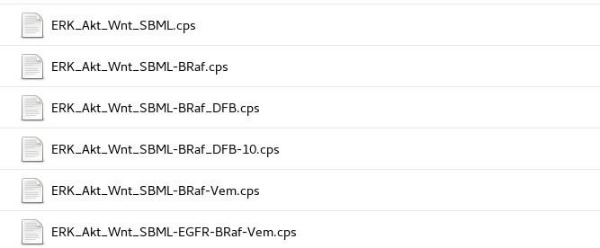

The steps outlined below can be used to display the effects of BRaf mutation on the concentration profile of Padala2017 et al. [10]- ERK, PI3K/Akt, and Wnt signaling network.

* Import the healthy model ERK_Akt_Wnt_SBML.cps
* Import the mutated model ERK_Akt_Wnt_SBML-Braf.cps (formed by deleting reactions 17a and 17b from the first model).
* Select time-course in the “Enter Specifics” dialog, with Duration=15000 and Intervals = 15000
* Run
  + Simulated concentration values of the models will appear in a new column on their respective Cytoscape node tables.

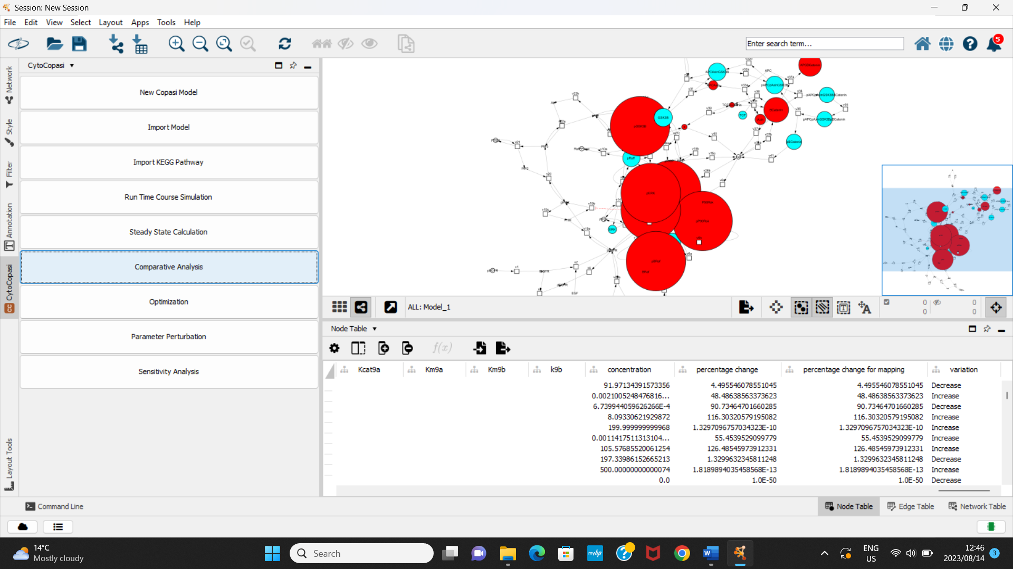

***Figure 19: Concentrations Appear in a New Column***

The BRaf-mutated Cytoscape network will be updated according to the alterations with respect to ERK_Akt_Wnt_SBML.cps. The node sizes of the metabolites or reactions will change depending on the fold change between the simulation results from the two models. The larger the absolute value of the fold change, the bigger the node becomes. Red and Cyan colors indicate upregulation and downregulation, respectively.

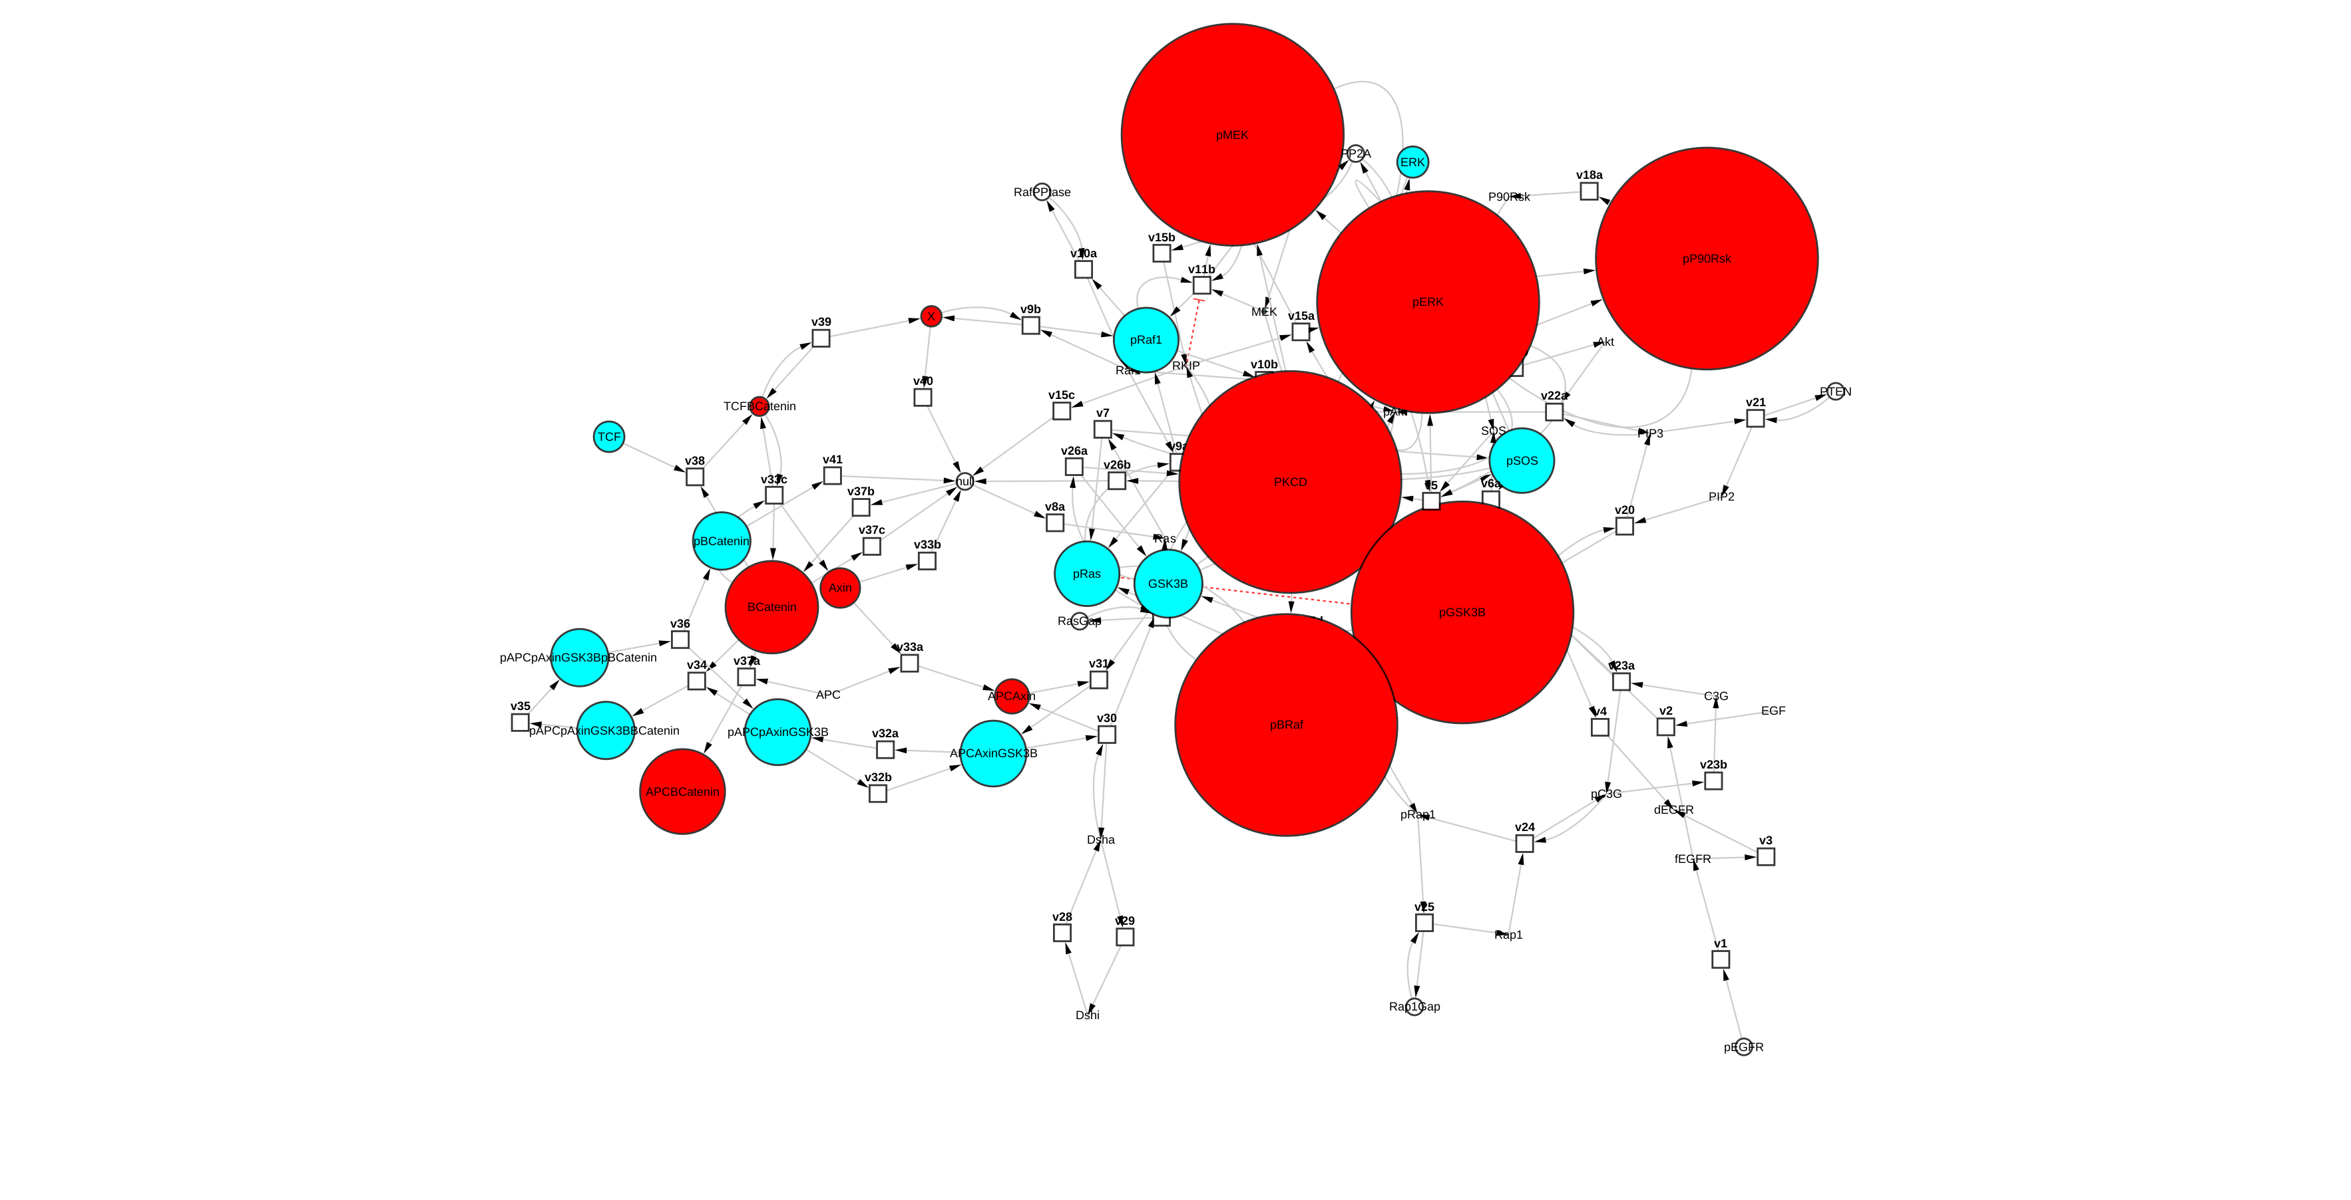

*Figure 20: The Devations in the BRaf-Mutated Signaling Model relative to the Healthy Signaling Model*

To observe the fold changes for each node, simply hover the cursor over them.

The reset button resets the Cytoscape network view, and the nodes become unified in size and color until the next comparison.

If you want to display how Vemurafenib treatment affects the concentration profile of the BRaf-Mutated signaling network, you need to repeat the steps with ERK_Akt_Wnt_SBML-BRaf.cps as the first model and ERK_Akt_Wnt_SBMLBRafVem.cps as the second model.

To find out whether treating the model with Vemurafenib brings the concentration profile back to the healthy values, repeat the steps with

* ERK_Akt_Wnt_SBML.cps as the first model and
* ERK_Akt_Wnt_SBML-BRaf-Vem.cps as the second model.

## 8.4- Parameter Perturbations on the Same Model

CytoCopasi’s parameter perturbation feature runs two sequential ODE simulations on the same model while tweaking one or more parameters of interest. In other words, you can manually perturb the model and display the subsequent impact on simulation results of the same model.

The parameter(s) to tweak include reaction parameters (i.e., enzyme activity) or the initial concentration of a metabolite (e.g., an inhibitor).

The example below demonstrates the use of parameter perturbation to display the effect of EGFR overexpression and mutation on the signaling network.

* Import the healthy model ERK_Akt_Wnt_SBML.cps
* Click on Parameter Perturbation from the Panel
* Click on “Add a New Perturbation Item” at the top of the parameter perturbation window.
* Find the reaction v1
  + - pEGFR = fEGFR
    - (This is for the conversion of pro-EGFR to free EGFR)
* Find the parameter V1 and click once
* The initial value is automatically entered as the original value from the model, but you can change it for the simulation to start with a specific value of V1
* Enter 4000 for the final value. This will show what happens to the final concentrations when you increase V1 from 100 to 4000. Click OK

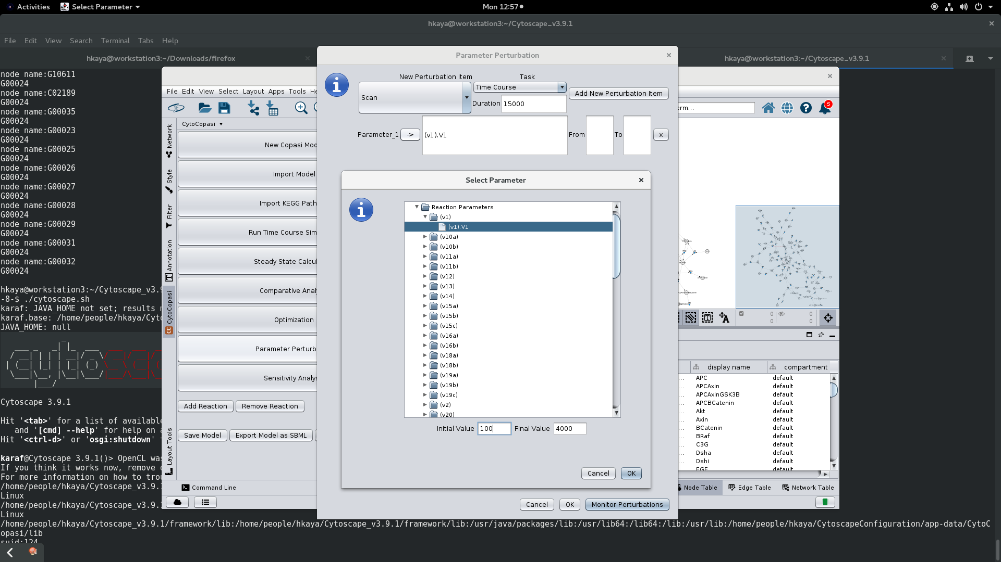

***Figure 21: Parameter Selection - Perturbing the V1 value of the reaction v1***

* Run:
  + The parameter perturbation will prompt the rearrangement of the network.
  + New columns will appear in the node table: Initial Concentration, Final Concentration, Perturbation, and Change%
  + The node size and color is determined by how much the concentration profile is upregulated/downregulated by increasing V1 by 40 folds. (In this case, you won’t see any colors or node growth, which means that the parameter has not perturbed the simulation output significantly.

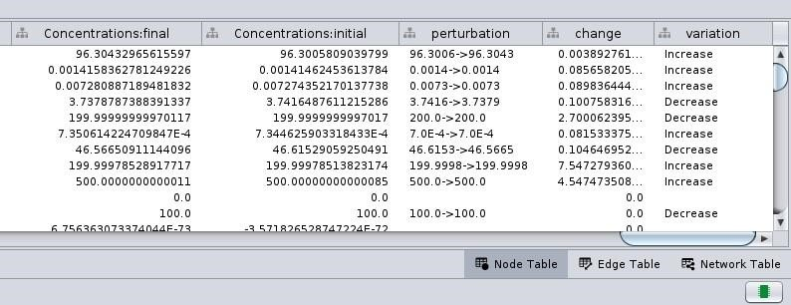

*Figure 22: Perturbation Results - The concentrations before and after the perturbation appear in two separate columns. The fold change is used to readjust node color and size. The bigger the node, the bigger the impact of the perturbation on that node*

You can run a multiple parameter perturbation, which prompts CytoCopasi to run 2n simulations for n parameters. It will compare the concentration changes between: - the model with the initial values of the parameters and (first simulation) - the model with the final parameter of the parameter (2nth simulation).

The combination of EGFR overexpression and inhibition of EGFR degradation can be demonstrated in this way.

* Follow the single parameter perturbation steps 1-7.
* Click on “Add a perturbation item”
* Find the reaction V4
  + bEGFR = dEGFR
  + B is for bound and d is for degraded
  + V = k4 * [bEGFR]
* Select k4.
* Enter 0.2 for the initial value and 0.005 for the final value

*Figure 23: Perturbation of Multiple Parameters*

* Run:
  + The parameter perturbation will prompt the rearrangement of the network.
  + New columns will appear in the node table: Concentration: Initial, Concentration: Final, Perturbation, and Change%

The node size and color are determined by how much the concentration profile is upregulated/downregulated by changing two parameters. (you will recognize that many cancer hallmarks in the signaling network, such as pERK and pMEK, are upregulated. This shows the significance of Egfr degradation in healthy cell signaling. )

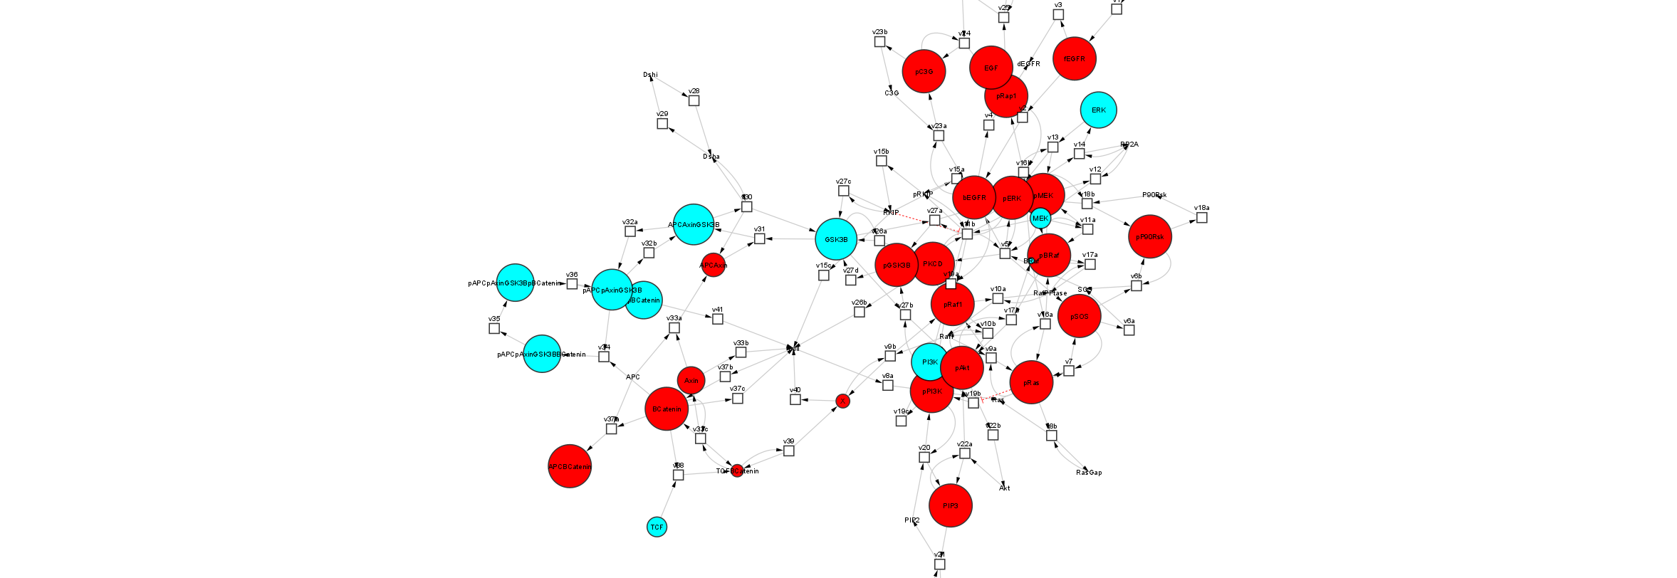

*Figure 24: Impact of Perturbing Two Parameters on the Concentration* Profile

To demonstrate the effect of vemurafenib when a BRaf-mutated network undergoes Egfr mutation, import ERK_Akt_Wnt_SBML-BRaf-EGFR -Vem.cps. This requires a parameter perturbation with three parameters: two from the previous perturbation example, and the third one being the initial Vem concentration (an increase from 0 to 1000 nM).

# 9- References

1. Shannon, P., et al., *Cytoscape: a software environment for integrated models of biomolecular interaction networks.* Genome research, 2003. **13**(11): p. 24982504.
2. Hoops, S., et al., *COPASI—a complex pathway simulator.* Bioinformatics, 2006. **22**(24): p. 3067-3074.
3. Hucka, M., et al., *The systems biology markup language (SBML): a medium for representation and exchange of biochemical network models.* Bioinformatics, 2003. **19**(4): p. 524-531.
4. Kanehisa, M. and S. Goto, *KEGG: kyoto encyclopedia of genes and genomes.* Nucleic acids research, 2000. **28**(1): p. 27-30.
5. Schomburg, I., A. Chang, and D. Schomburg, *BRENDA, enzyme data and metabolic information.* Nucleic acids research, 2002. **30**(1): p. 47-49.
6. Dörr, A., et al., *SBMLsimulator: a Java tool for model simulation and parameter estimation in systems biology.* Computation, 2014. **2**(4): p. 246-257.
7. König, M., A. Dräger, and H.-G. Holzhütter, *CySBML: a Cytoscape plugin for SBML.* Bioinformatics, 2012. **28**(18): p. 2402-2403.
8. Wrzodek, C., A. Dräger, and A. Zell, *KEGGtranslator: visualizing and converting the KEGG PATHWAY database to various formats.* Bioinformatics, 2011. **27**(16): p. 2314-2315.
9. Gilbert, D. and T. Morgner, *JFreeChart.* Availab le at [http://www.](http://www/) jfree. org/jfreechart/index. html, 2009.
10. Padala, R.R., et al., *Cancerous perturbations within the ERK, PI3K/Akt, and Wnt/β-catenin signaling network constitutively activate inter-pathway positive feedback loops.* Molecular BioSystems, 2017. **13**(5): p. 830-840.